# Assignment 1:

Create a HTML webpage from wireframe given below:

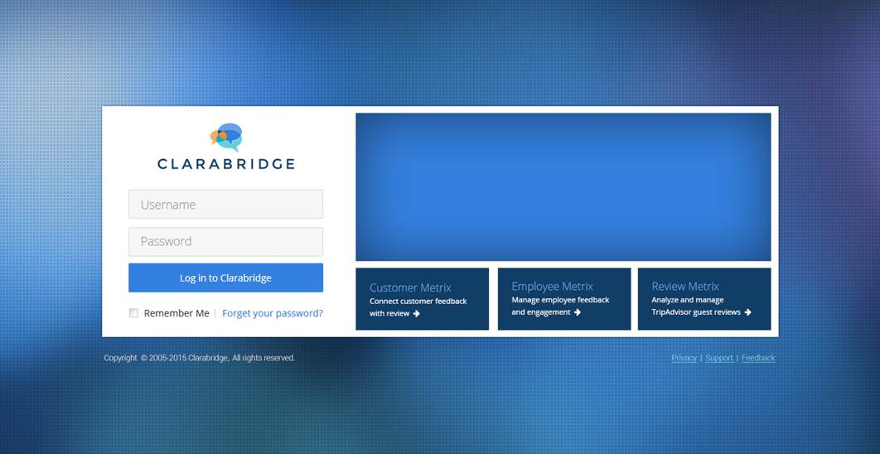

### Instruction:

1. Create Basic HTML Page using HTML and CSS.
2. No need to add any JavaScript or any JS

# Assignment 2:

Make HTML webpage created in Assignment1 responsive using Bootstrap.

### Instruction:

1. Use the same HTML from the assignment1 and add bootstrap.js
2. Use Simple CSS components of Bootstrap like container, row, col etc.

# Assignment 3:

Create sign up page with Name (mandatory), surname (not mandatory), email(mandatory and validate it), Mobile number (mandatory and user cannot be enter greater and less than 10 digits), landline (not mandatory).

### Instruction:

1. You can take take email validator regex from internet.

# Assignment 4:

Create a quiz question (1 radio type, 1 checkbox, 1 textbox). Print the User entered value and evaluate it.

# Assignment 5:

Make a table using Angular JS Basic Directives, wireframe given below:

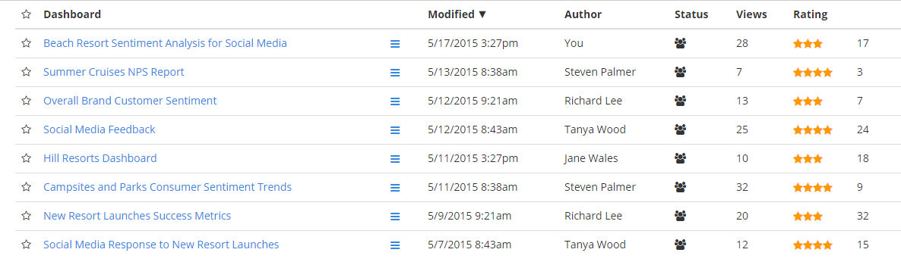

### Instruction:

1. Create the data in Json using factory directive which is to be shown.
2. Use Angular Js ng-repeat directive for showing the data

# Assignment 6:

Make a tile template for mobile view using Angular Custom Directive, wireframe given below:

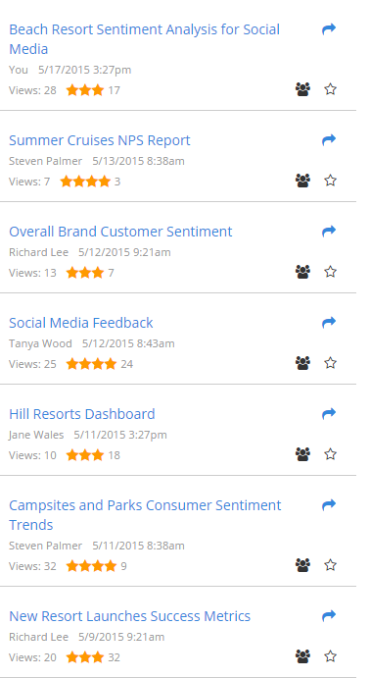

### Instruction:

1. Use the same HTML of Assignment 3.
2. Create a custom directive whose template will be tile (wireframe above)
3. Now check the window size and swap the table view and tile view.
4. Hint: use ngInclude with condition inside template.

# Assignment 7.1:

Create a sample webpage to use Highcharts.js using Angular

### Instruction:

1. Use ng-highcharts for Highcharts with Angular.

# Assignment 7.2:

Create a sample webpage to use gridster.js using Angularjs

# Assignment 7.2:

1.Create a sample webpage to use Gridster.js using Angular

# Assignment 7.3:

1.Create a sample webpage to use Highcharts.js and Gridster.js using Angular

# Assignment 7.4:

Create this demo: <http://jsfiddle.net/pablojim/cp73s/>

# Assignment 8:

Create a webpage to display survey builder having at least 3 types of directives visible according to question type

### Instruction:

1. Create Directives for each type of question like Single Text , Multiple Choice or Multiple Choice with dropdown
2. Create the sample data model for question type.
3. Use all the created directives in survey builder page and display as per question type.
4. Demo: Survey Builder in cb-broklyn

# Assignment 9:

Create a webpage to show the collapsible tree for nested tree data structure using angular JS features.

### Instruction:

1. Create Nested Tree Data Model
2. Use recursion with ng-include to include the template .

# Assignment 10:

Create web page look like this:

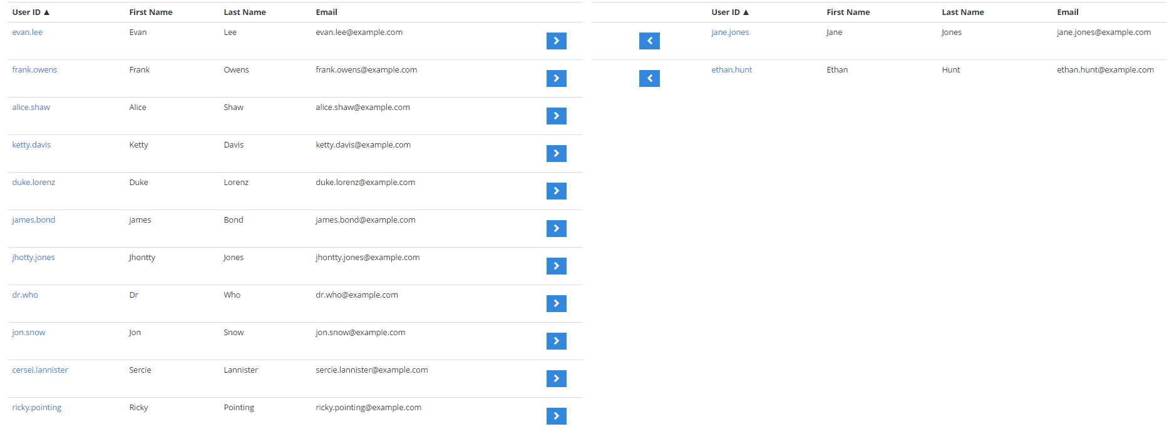

### Instruction:

1. Create with ng-repeat